Source https://deluxeiceland.is/luxury-tours/family-winter-adventure/
__________________________________________________________

Family Winter Adventure Tour in Iceland
__________________________________________________________
★★★★★ 4.7/5 20 reviews

Add to wishlist ♡

__________________________________________________________

6 days | From €3,655 per person

🏕  Image | 🏕  Image | 🏕  Image | 🏕  Image | 🏕  Image | 🏕  Image

__________________________________________________________
About This Tour
Embark on a 6-day private adventure through the heart of Iceland’s most captivating winter landscapes. Tailored for families, this tour combines adventure with relaxation, making it perfect for families with young children. From soaking in the geothermal waters of the Blue Lagoon to exploring glaciers, waterfalls, and volcanoes, you’ll experience Iceland’s natural wonders while creating lifelong memories with your loved ones. End the tour with the breathtaking Northern Lights illuminating the winter sky.
__________________________________________________________
What’s Waiting for You
- Duration: 6 days / 5 nights
- Group Size: Private group, ideal for families
- Accommodation: 3 nights at Hotel Rangá, 2 nights at Hotel Borg (Deluxe Room with breakfast)
- Languages Available: English, Spanish, French
- Private Guided Tour: Fully personalized experience with your own guide
- Transportation: Comfortable, private transportation throughout your trip
- Season: Available from 1 October to 15 April
__________________________________________________________

Check Dates & Availability

Select participants: (Age 99 and younger) - 1 +

Choose date:
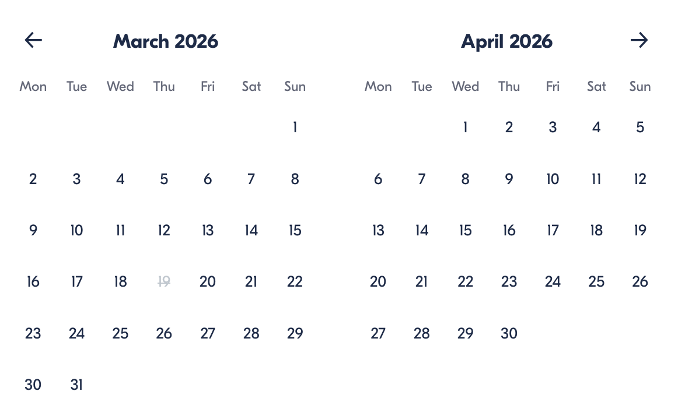

Check Availability

opens:

Participants: 2 March 16, 2026

Family Winter Adventure Tour in Iceland

- Duration: 6 days
- Offered in: English
- Starts at: 10:30 AM

Cancellation:

- More than two weeks prior to arrival: 40% Credit / 60% Refunded
- Less than two weeks prior to arrival: 50% Credit / 50% Refunded
- Less than 72 hours prior to arrival: No refund and no credit

Price breakdown: 2 Participants x €3,655

Total: €7,310

The total price includes all taxes and fees.

Add to cart Book now

__________________________________________________________
Tour Features
- Blue Lagoon: Relax in the world-famous geothermal spa.
- Golden Circle: Explore geysers, waterfalls, and volcanic landscapes.
- South Coast Wonders: Visit iconic waterfalls like Seljalandsfoss and Skogafoss.
- Geothermal Pool and Lava Center: A unique, educational experience about Iceland’s geothermal energy.
- Northern Lights Viewing: Witness the magic of the Northern Lights from a perfect vantage point.
__________________________________________________________
Detailed Itinerary
- Day 1 – Arrival & Blue Lagoon Relaxation
Welcome to Iceland! Upon your arrival at Keflavik Airport, your private driver will meet you and take you straight to the world-renowned Blue Lagoon. Soak in the warm, healing geothermal waters, surrounded by stunning volcanic landscapes, with premium access to the lagoon. After your relaxing time, your driver will escort you to your accommodation at Hotel Rangá in South Iceland, where you can unwind and get ready for the adventures ahead.
Accommodation:
Hotel Rangá, South Iceland – Deluxe Room with breakfast (Included in price)
__________________________________________________________
- Day 2 – South Coast Wonders
Get ready to explore Iceland’s magnificent South Coast! Your adventure begins with a visit to Reynisfjara black sand beach, where you’ll marvel at the Reynisdrangar Cliffs and their stunning sea stacks. After taking in the breathtaking coastal views, head to Skógafoss, one of Iceland's largest and most majestic waterfalls. You’ll even have the chance to get up close to the falls and feel the mist! Before heading back to the hotel, stop by Seljalandsfoss, a waterfall you can walk behind for an incredible experience. In the evening, relax at Hotel Rangá.
Accommodation:
Hotel Rangá, South Iceland – Deluxe Room with breakfast (Included in price)
__________________________________________________________
- Day 3 – Lava Center, Farm Visit & Geothermal Swimming
Start your day with a visit to the Lava Center, where you’ll learn about Iceland’s volcanic history and geology. Next, enjoy a cozy stop at a local farm to experience Icelandic farm life firsthand, enjoy a traditional Icelandic pancake, and sip a warm cup of coffee. Afterward, take a dip in a geothermal swimming pool in the town of Hella, where both adults can relax, and kids can splash around. Finish the day feeling rejuvenated before returning to your hotel.
Accommodation:
Hotel Rangá, South Iceland – Deluxe Room with breakfast (Included in price)
__________________________________________________________
- Day 4 – The Golden Circle Adventure
Today, you’ll embark on Iceland’s famous Golden Circle route. Start with a visit to Gullfoss, one of Iceland's most iconic waterfalls, where you’ll see water tumble dramatically over two stages. Next, visit the Geysir Geothermal Area, home to the lively Strokkur geyser, which erupts every few minutes, sending water 30 meters into the air. Finally, explore Þingvellir National Park, a UNESCO World Heritage site where you can learn about Iceland's rich history and hike through the rift valley, where the North American and Eurasian tectonic plates meet. End the day in Reykjavik at Hotel Borg.
Accommodation:
Hotel Borg, Reykjavik – Deluxe Room with breakfast (Included in price)
__________________________________________________________
- Day 5 – Discover Reykjavik
Spend the day at your own pace, discovering Reykjavik, Iceland’s charming capital. Stroll through the heart of the city, where you’ll find shops, cafes, museums, and galleries. Visit the Harpa Concert Hall, stroll along the harbor, or enjoy the many family-friendly activities available throughout the city. You’ll have plenty of time to explore and make your own discoveries. In the evening, unwind and enjoy a relaxing dinner in one of the city’s renowned restaurants.
Accommodation:
Hotel Borg, Reykjavik – Deluxe Room with breakfast (Included in price)
__________________________________________________________
- Day 6 – Departure
On your last day, your private driver will pick you up from the hotel and take you to Keflavik Airport for your departure. Be sure to arrive 2 hours before your flight’s departure to ensure a smooth check-in process. Reflect on your amazing journey through Iceland's winter wonderland as you head back home with unforgettable memories.
__________________________________________________________
Included in Price
- Private guide for the duration of the tour
- Private transfers between attractions and hotels
- Premium tickets to the Blue Lagoon
- Entrance fees to the Lava Center
- Farm visit with guided tour
- Accommodation: 3 nights at Hotel Rangá, 2 nights at Hotel Borg (Deluxe Room with breakfast)
- All taxes and fees – no hidden charges
__________________________________________________________
Not Included
- Meals (Lunches and dinners not included)
- International flights
- Optional activities such as snowmobiling or ATV tours (can be added at an extra cost)
__________________________________________________________
Who Should Avoid This Tour
- Pregnant Travelers: Due to the physical nature of activities such as snowmobiling and glacier hiking, this tour may not be ideal for pregnant travelers.
- Travelers with Mobility Issues: While the tour is family-friendly, some locations, such as the Golden Circle and South Coast, involve walking on uneven terrain and may not be suitable for individuals with limited mobility or those in wheelchairs.
- Heart Conditions: Activities such as snowmobiling and hiking, as well as the cold temperatures in Iceland, may not be suitable for travelers with heart conditions or severe medical issues. Please consult your doctor before booking.
- Very Young Children: Although the tour is family-oriented, some excursions, such as the Northern Lights hunt and longer day trips, may be challenging for children under 3 years of age due to the cold or extended activity times.
__________________________________________________________
Important Trip Info
- Tour Duration: This is a 6-day tour with some longer days of exploration. Be prepared for full days of sightseeing, with activities that may involve physical exertion, such as walking, hiking, and occasional long drives.
- Weather Considerations: Iceland is known for its unpredictable weather. Bring layers, including waterproof clothing, gloves, and a hat. Expect cold, windy conditions even during the summer months.
- Accommodation: You will be staying in luxury, family-friendly hotels with breakfast included. Rooms at Hotel Rangá and Hotel Borg are equipped for comfort during your stay.
- Food and Meals: Meals are not included in the tour price, but we recommend enjoying the local Icelandic cuisine. There are plenty of restaurants near your accommodation offering delicious options. We suggest bringing snacks for the journey, especially for longer travel days.
- Northern Lights: While we strive for clear skies, the Northern Lights are a natural phenomenon, and sightings cannot be guaranteed. However, your guide will take you to the best viewing spots to maximize your chances.
- Physical Readiness: Most travelers can participate, but activities such as hiking and snowmobiling require a basic level of physical fitness. If you or your children have concerns, please contact us to discuss your specific needs.
- Time Zone: Iceland operates on GMT/UTC. Make sure to set your watches and devices to the local time.
- Punctuality: It’s important to be on time for all activities and pick-ups. The tours are planned with specific departure times, especially for the Golden Circle and Northern Lights excursions.
- Emergency Contacts: In case of emergencies, we’ll provide you with local contact details and your tour guide’s phone number. Our team is available 24/7 for urgent matters.
__________________________________________________________

Cancellation Policy
For 5 or Fewer Participants:
- More than 2 weeks before arrival: 40% Credit / 60% Refund
- Less than 2 weeks before arrival: 50% Credit / 50% Refund
- Less than 72 hours before arrival: No refund or credit
For 6 or More Participants:
- More than 4 weeks before arrival: 40% Credit / 60% Refund
- Less than 4 weeks before arrival: 80% Credit / 20% Refund
- Less than 2 weeks before arrival: No refund or credit
Changes in the number of participants may increase the price per person. We recommend comprehensive travel insurance.
Weather-Related Cancellations:
If activities are canceled due to weather, they will be fully refunded. Itineraries may change based on conditions, with safety as the top priority.
Refund Processing:
Refunds are processed within 15 days after the tour ends.
__________________________________________________________
What Our Clients Are Saying

Overall rating  4.7/5  ★★★★★  Based on 20 reviews | Review summary  Guide 4.5/5  Transportation 4.6/5  Service 4.7/5  Organisation 4.5/5

Filter  - All traveller types  - Couples  - Group of friends  - Families  By star rating  - All star ratings  - 5 stars  - 4 stars  - 3 stars  - 2 stars  - 1 star | Search reviews (e.g., guide)  Sort by:  - Top picks  - Latest reviews  - Best ratings  - Lowest ratings
__________________________________________________________
★★★★★
Emily J. – United States of America
Our family had the best time in Iceland. The kids loved the farm visit, and the Blue Lagoon was so relaxing after a day of adventure. Highly recommend this tour!

★★★★★
Oliver F. – Germany
This tour was the perfect family vacation. The guides were knowledgeable and fun, and the Northern Lights were the highlight of our trip!

★★★★☆
Sophia D. – United Kingdom
A fantastic experience! I wish we had a little more time in Reykjavik, but the overall trip was amazing. The kids had a blast!

See more reviews
__________________________________________________________

Meta tags

Page - Family Winter Adventure Tour in Iceland

Title: Family Winter Adventure Tour in Iceland | Travellio Global

Description: Embark on a 6-day family-friendly adventure through Iceland’s stunning landscapes. Explore waterfalls, geothermal spas, the Golden Circle, and more with your private guide. Ideal for families with children.

H1 - Family Winter Adventure Tour in Iceland
__________________________________________________________

